LABORATORY WORK 7. STORED PROCEDURES

Formulation of the problem
Here we will create stored procedures with different structures for dynamic queries, that is, the input data can be flexible. Stored procedures can nest each other up to 32 times, and you need to use this to create a chain of dynamic queries that are logically related to each other. We will create a stored procedure that calls several other stored procedures. You also need to learn how to draw conclusions of different output data formats (that is, both in the form of tables and in the form of strings) in one stored procedure at the same time.

Topics for study
- Creating stored procedures
- Calling one stored procedure to another
- Output multiple outputs in different formats when performing the same procedure

Perform the task using the own database. Data and examples must be individual, duplicate tasks and the results are not accepted.

- Create custom stored procedures to create dynamic queries. The input data must be variable. Apply the possibilities of expression LIKE% _ etc. Stored procedures removal, modification.
- Create a stored procedure with default values.
- Create a stored procedure with a notice on the successful implementation of the process. (using “if”
condition).
- Create a stored procedure that calls another procedure. The need must be justified.
- Multivalued data output as a result of several stored procedures call at the same time.

For example, consider a table Faculties and Tutors (here are operators for creation and data adding to represent the structure of tables):

Task #1

Create custom stored procedures to create dynamic queries. The input data must be variable.
Apply the possibilities of expression LIKE% _ etc. Removal, modification st.procedure

The result: Create a procedure output of the list of all faculty members whose names begin with the specified user token.
The command to create the procedure:
CREATE PROCEDURE FindVenue
@token VARCHAR(50)
AS
BEGIN
SELECT *
FROM Venue
WHERE venue_name LIKE @token + '%'
END;
EXEC FindVenue 'Ast';
The procedure execution:

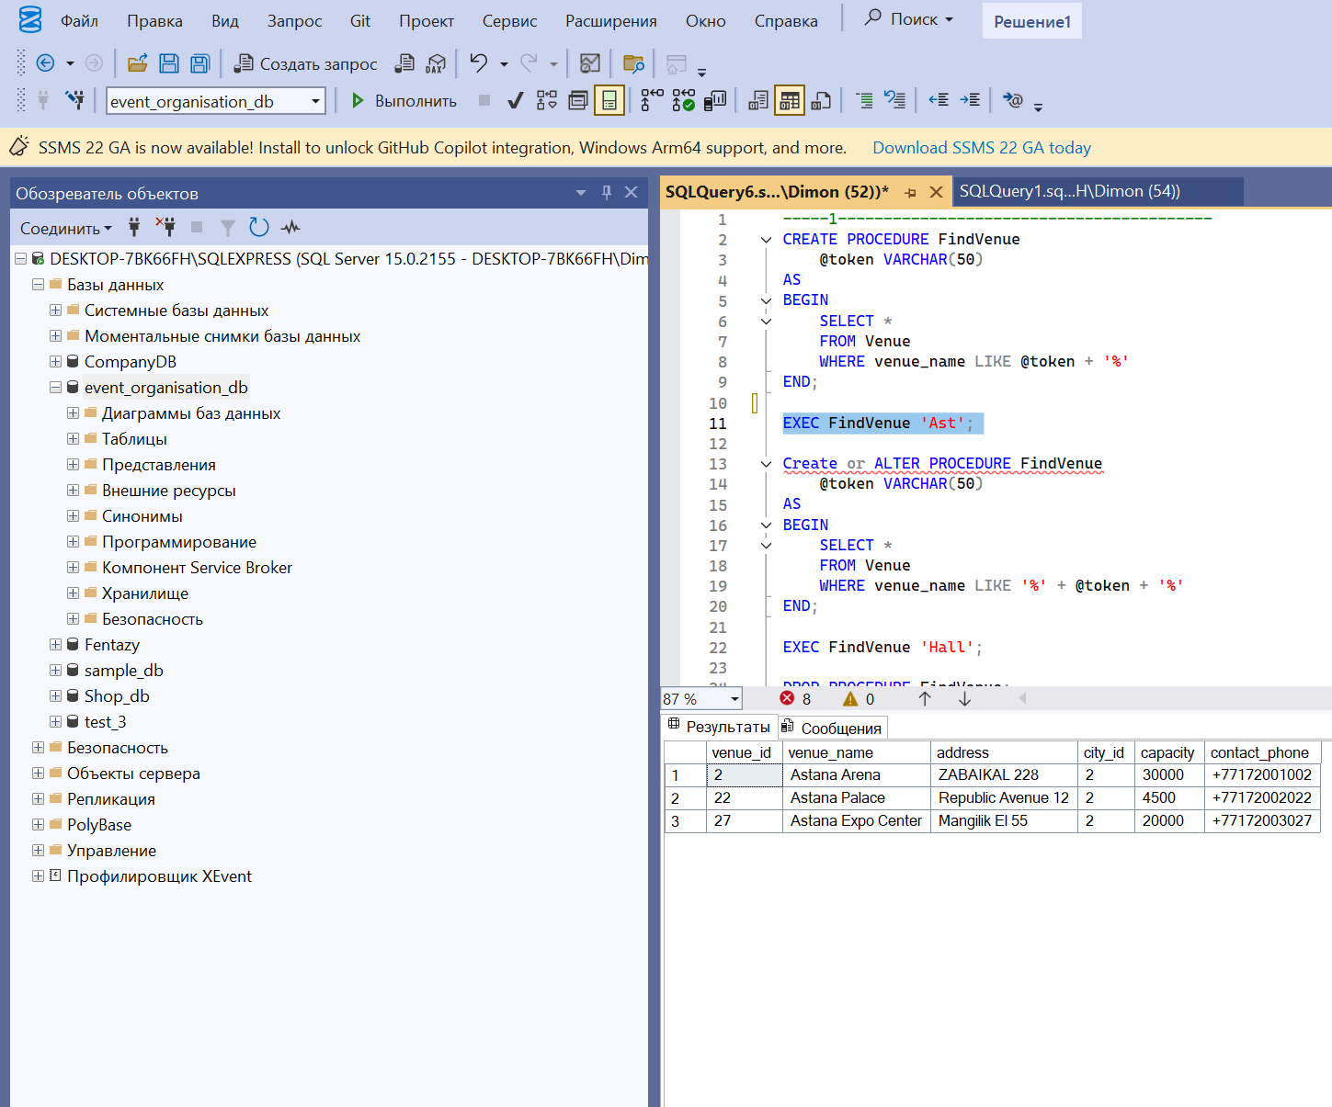

Modify the procedure as follows: list the faculty members whose names contain the substring specified by the user

The command to create the procedure:
Create or ALTER PROCEDURE FindVenue
@token VARCHAR(50)
AS
BEGIN
SELECT *
FROM Venue
WHERE venue_name LIKE '%' + @token + '%'
END;

EXEC FindVenue 'Hall';
Procedure verification:
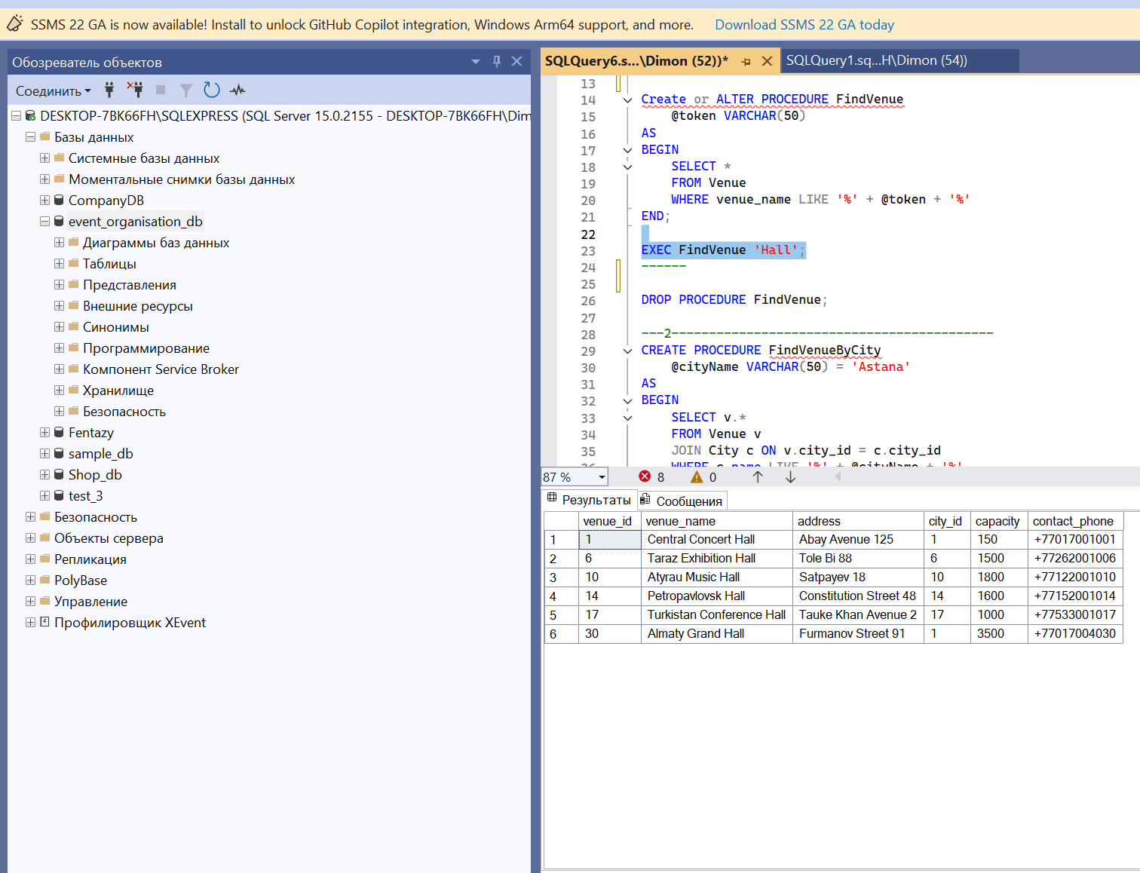
Procedure removal command:

DROP PROCEDURE FindVenue;

Checking:
EXEC FindVenue 'Hall';
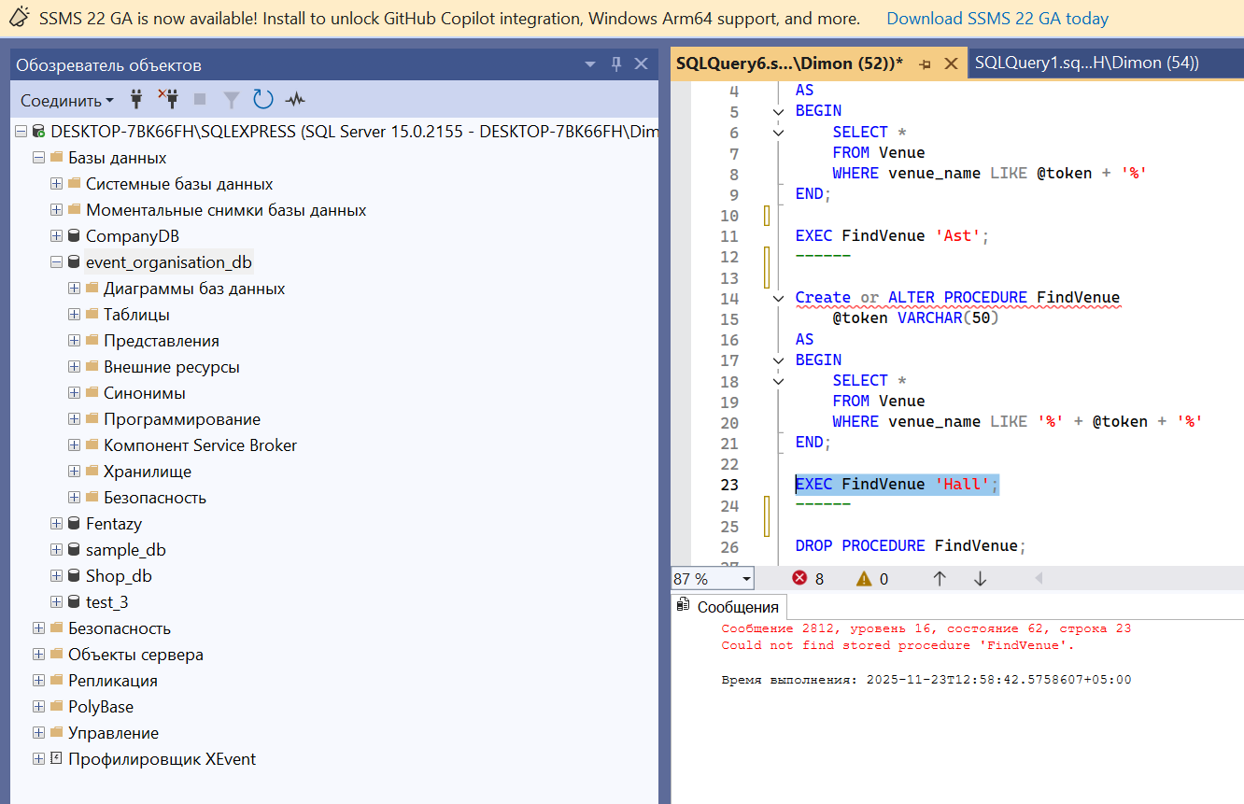

Task #2
Create a stored procedure with default values
The result: modify the “show” procedure, defining the substring default 'FIT'. Procedure modification command:

CREATE PROCEDURE FindVenueByCity
@cityName VARCHAR(50) = 'Astana'
AS
BEGIN
SELECT v.*
FROM Venue v
JOIN City c ON v.city_id = c.city_id
WHERE c.name LIKE '%' + @cityName + '%'
END;
EXEC FindVenueByCity;
EXEC FindVenueByCity 'Almaty';
Procedure execution command:

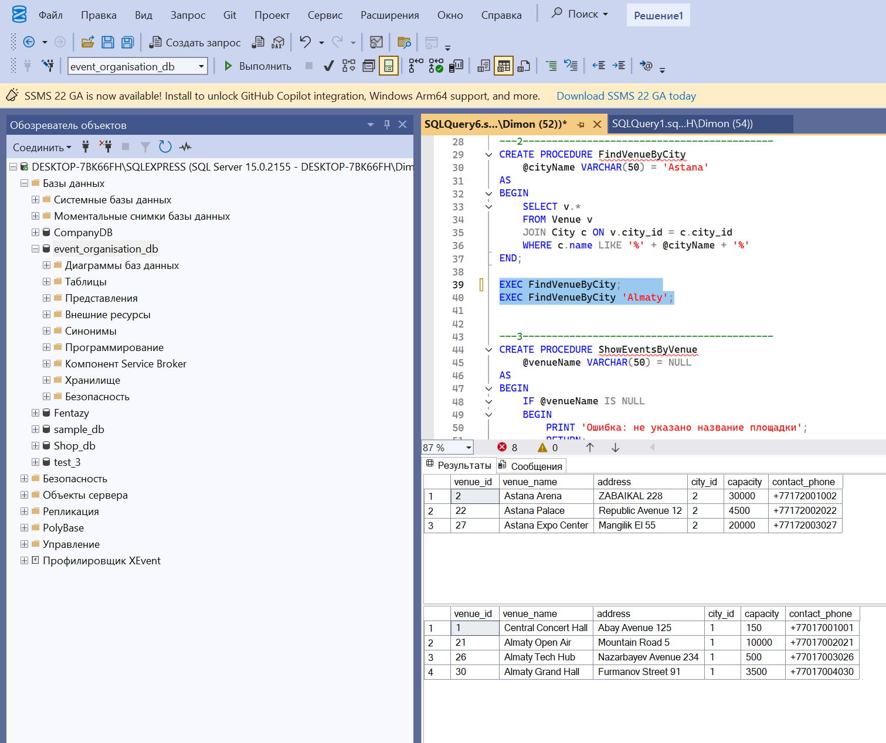

Task #3

Create a stored procedure with a notice on the successful implementation of the process. (Using
“if” condition).

The result: Modify the procedure: Add a warning that there is no search terms and the lack of data that satisfy the query.

Procedure modification command:

CREATE PROCEDURE ShowEventsByVenue
@venueName VARCHAR(50) = NULL
AS
BEGIN
IF @venueName IS NULL
BEGIN
PRINT 'Ошибка: не указано название площадки';
RETURN;
END;

IF EXISTS (
SELECT * FROM Venue WHERE venue_name LIKE '%' + @venueName + '%'
)
BEGIN
PRINT 'Список мероприятий:';
SELECT e.*
FROM Event e
JOIN Venue v ON e.venue_id = v.venue_id
WHERE v.venue_name LIKE '%' + @venueName + '%';
END
ELSE
BEGIN
PRINT 'Площадка не найдена!';
END;
END;
EXEC ShowEventsByVenue NULL;
EXEC ShowEventsByVenue 'ANIME';
EXEC ShowEventsByVenue 'Are';
Procedure verification:
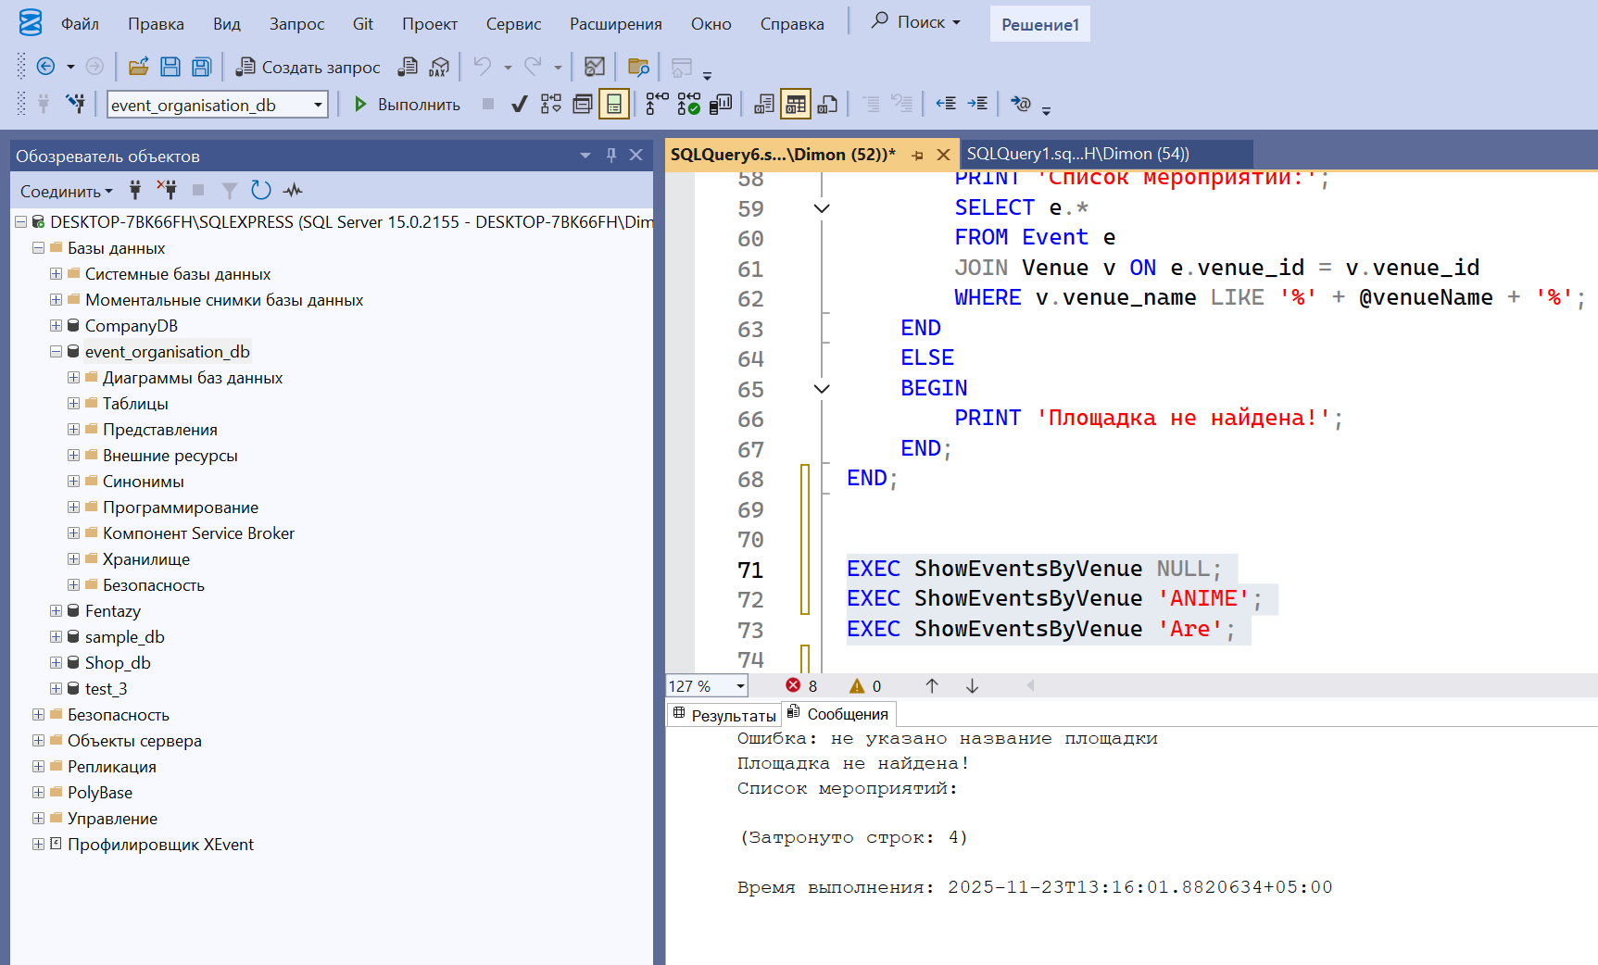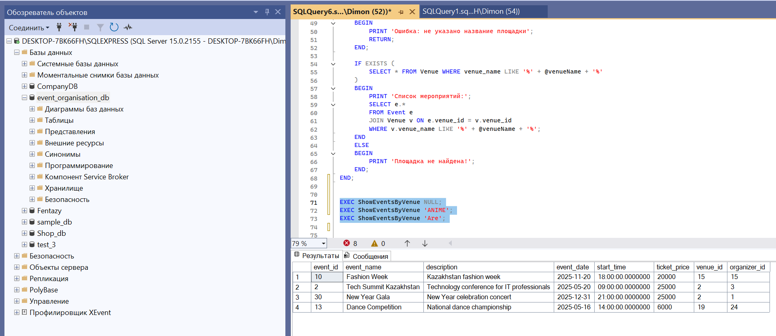

Task #4

Create a stored procedure that calls another procedure. The need must be justified.

The result: Create a new procedure that displays a list of teachers given faculties, and list of phone numbers of these phones. For this case, you must use the above procedure call in the body of the new procedure
The command to create the procedure:

CREATE PROCEDURE FindEvent
@token VARCHAR(50)
AS
BEGIN
SELECT event_id, event_name, venue_id
FROM Event
WHERE event_name LIKE '%' + @token + '%'
END

CREATE PROCEDURE ShowEventWithVenue
@token VARCHAR(50)
AS
BEGIN
PRINT 'Поиск событий:';
EXEC FindEvent @token;

PRINT 'Информация о площадках:';
SELECT v.venue_id, v.venue_name, v.address, c.name AS city
FROM Venue v
JOIN City c ON v.city_id = c.city_id;
END;

EXEC ShowEventWithVenue 'Ro';
Procedure verification:
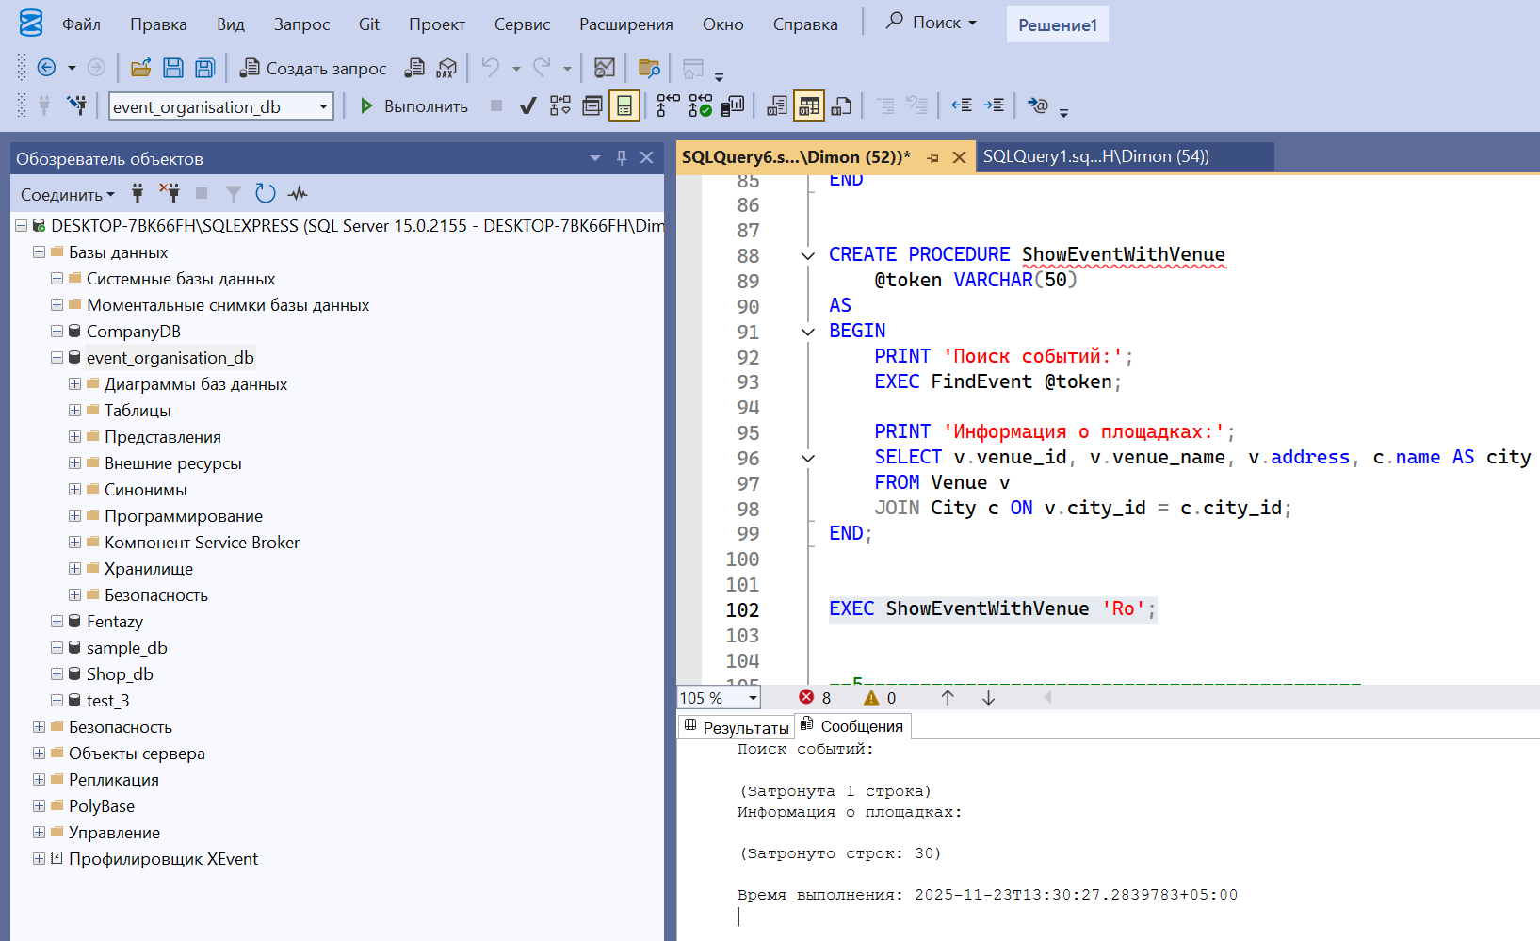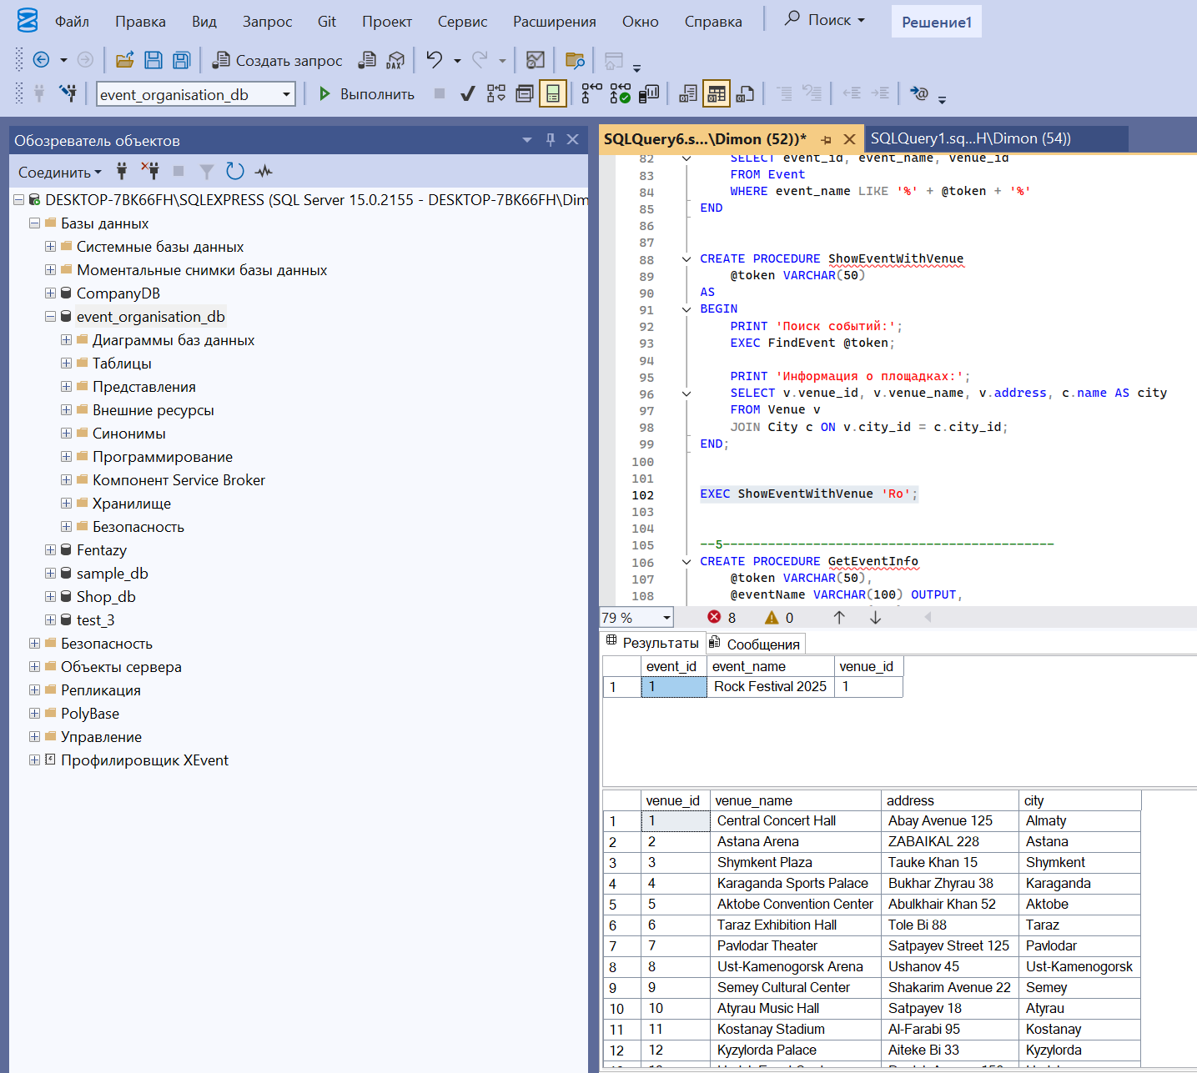

Task #5
Multivalued data output as a result of several stored procedures call at the same time

The result: Modify the created above procedure. One of them returns the name of the teacher and the department in which he works, and the other the faculty information as a report.

Procedure modification command:

CREATE PROCEDURE GetEventInfo
@token VARCHAR(50),
@eventName VARCHAR(100) OUTPUT,
@venueName VARCHAR(100) OUTPUT
AS
BEGIN
SELECT
@eventName = event_name,
@venueName = v.venue_name
FROM Event e
JOIN Venue v ON e.venue_id = v.venue_id
WHERE e.event_name LIKE '%' + @token + '%';
END;

CREATE PROCEDURE EventReport
@search VARCHAR(50)
AS
BEGIN
DECLARE @ev VARCHAR(100);
DECLARE @ven VARCHAR(100);

EXEC GetEventInfo @search, @ev OUTPUT, @ven OUTPUT;

PRINT '--- Описание мероприятия ---';
PRINT 'Название: ' + ISNULL(@ev, 'Не найдено');
PRINT 'Площадка: ' + ISNULL(@ven, 'Не найдено');

PRINT '--- Полная информация о площадке ---';

SELECT v.*, c.name AS city
FROM Venue v
JOIN City c ON v.city_id = c.city_id
WHERE v.venue_name = @ven;
END
Procedure verification:

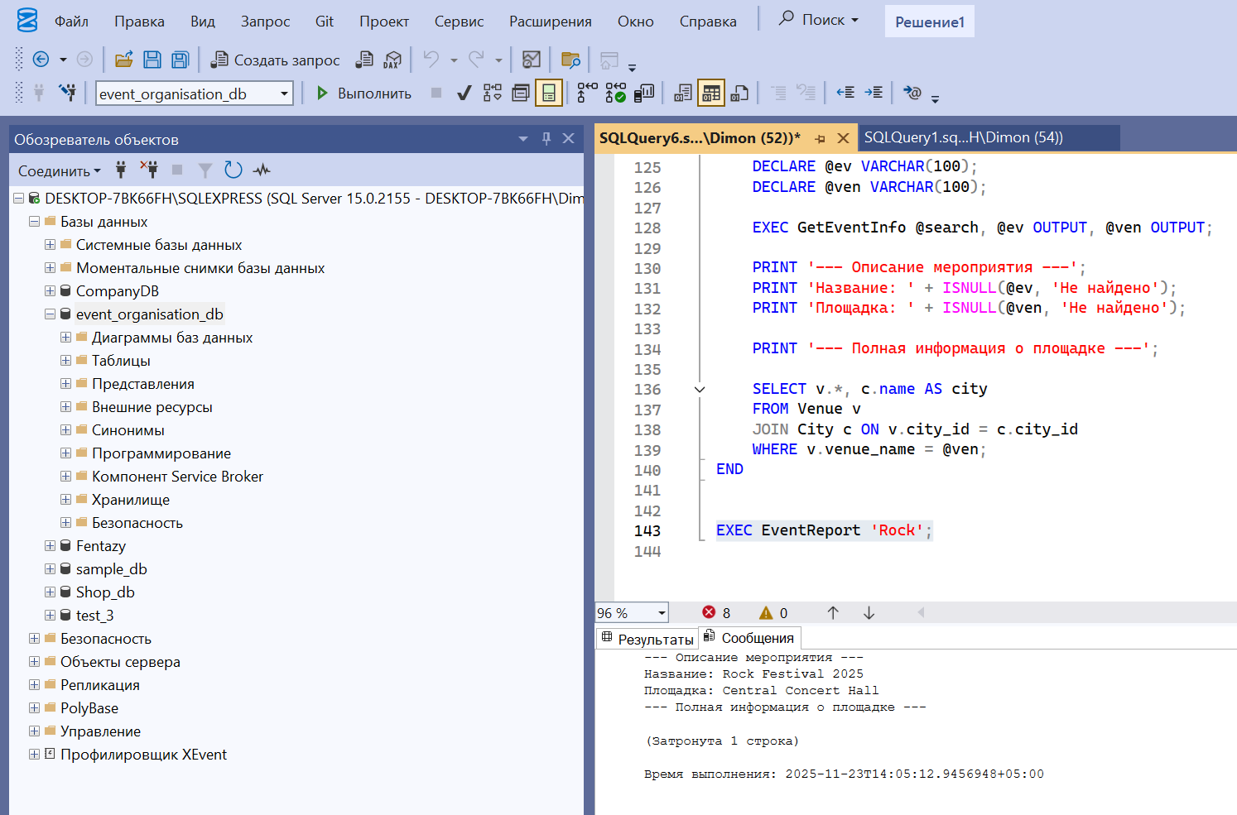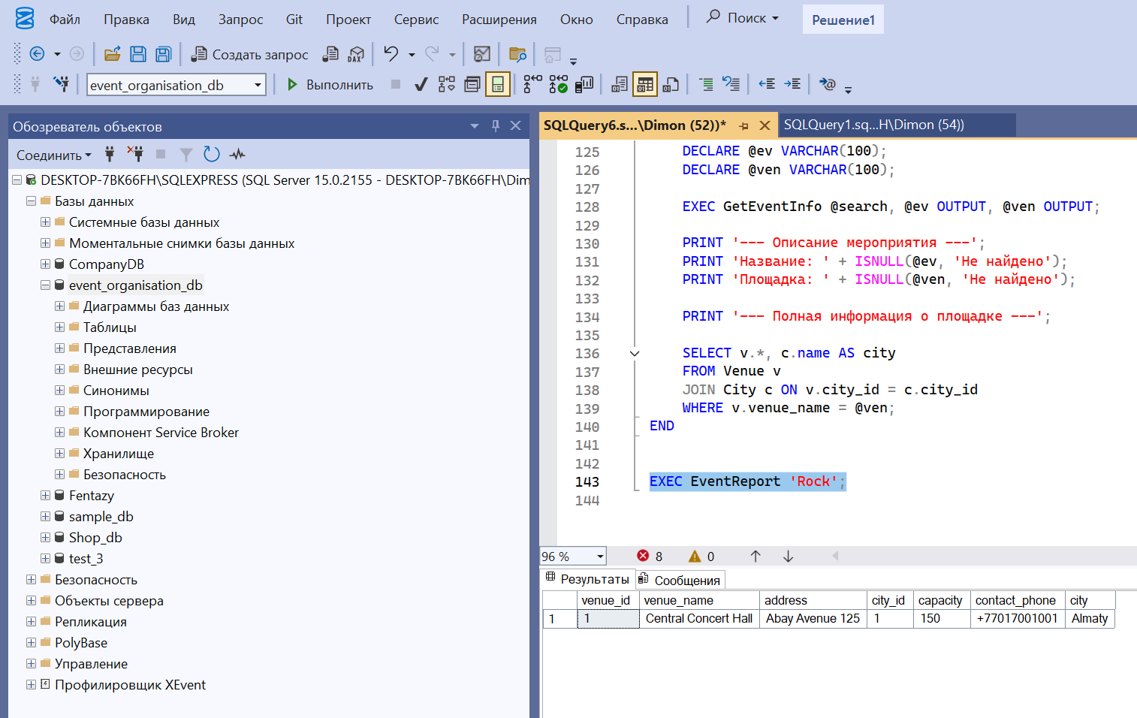

Examples of questions on the mandatory part:
*What are the types of stored procedures?
Процедуры без параметров

Процедуры с входными параметрами

Процедуры с выходными параметрами

CRUD-процедуры (создание, чтение, обновление, удаление)
*How is the stored procedure called?
EXEC ИмяПроцедуры;
EXEC ИмяПроцедуры @param = значение;

*How do I use variable inputs for a stored procedure?
CREATE PROCEDURE TestProc @id INT AS ...
EXEC TestProc @id = 5;

*How do I use multiple inputs in a stored procedure?
CREATE PROCEDURE TestProc @id INT, @name NVARCHAR(50) AS ...
EXEC TestProc @id = 5, @name = 'John';

